**Process 1:**

1. Determine required flow rate for system
   1. Pick bearings based on L/D ratio and crankshaft dimensions
      1. Calculate total leakage rate
   2. Calculate flow rate needed through intake/exhaust manifolds
      1. Splash lubrication from bearings on camshaft, same calculations as for crankshaft and connecting rod bearings
2. Pick pump
   1. This finalizes system flow rate
   2. And pressure
      1. Need to find major, minor losses
      2. Use flow rate to find velocity
3. Calculate diameter of oil channels through block and crankshaft (also intake/exhaust manifolds)
   1. Using flow rate
   2. Crankshaft channels
      1. Outer channels can be slightly longer with slightly lower pressures because they will have lower flow rates because they only support half the load of the central bearing
4. Implement channels into part design files

**Process 2:**

1. Design oil pan based on engine block design and required volume of oil (~4 litres)
   1. Must allow for safety factor for tilt, ac/deceleration (eliminate crankshaft dipping)
   2. Include drain plug
   3. Include considerations to ensure intake tube is always submerged
2. Design rest of components
   1. Dipstick
   2. Dipstick tube
   3. Oil manifold
   4. Oil pump mount
3. Spec rest of system components
   1. Intake tube
      1. Tube adapter (male)
   2. Drilling relief valve (after pump, before drilling entrance
   3. Bypass relief valve (before full flow filter)
   4. Piston relief valve (before piston cooling jet)
   5. Full flow filter
   6. Bypass filter
   7. Oil manifold mounting bolts

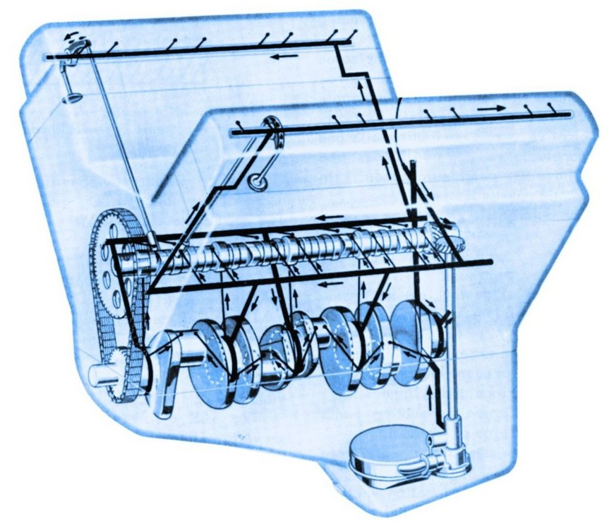

Lifter/pushrod lubrication:

<https://www.thecarguys.net/valve_system_operation.pdf>

**Bearing material:**

AST800 Bimetal Wrapped Steel With Bronze,

Good for lubricated applications, high load capacity, excellent heat dissipation, and good fatigue properties. They have been widely used in automotive industry